SECURITY ASSURANCE BRIEF

Broker / Agent Pathway Security Architecture
  - Executive view of the control architecture, protected data posture, assurance evidence, and production readiness model.
Prepared for | WHPS security, architecture, product, and platform leadership
Document type | Executive security architecture and assurance brief
Prepared date | May 21, 2026
Scope | Broker / agent pathway, ACA enrollment workflows, CMS/EDE integration, evidence stores, and operating controls
Evidence boundary | Architecture and control posture are documented here; operating effectiveness requires dated evidence artifacts and approved remediation disposition.

Executive security position
The Broker / Agent Pathway is governed as a regulated healthcare platform capability, not as a standalone user interface. The assurance model is built around four outcomes: authenticated and scoped access, protected transaction data, controlled integration boundaries, and evidence-backed operations.

Board-level assurance view
- Identity and role scope are the first control boundary: broker, agency, support, and consumer pathways must be separated by enterprise identity, MFA, role policy, and transaction context.
- Network and application ingress are controlled through DNS, reverse proxy, load balancing, WAF/F5 policy, secure transport, API gateway controls, and hardened application services.
- Protected data and CMS/EDE transaction evidence are handled through minimum-necessary access, encryption, masking, retention, audit logging, and reviewer-ready evidence packaging.
- Security posture is sustained through SAST, DAST, dependency review, vulnerability scanning, endpoint visibility, SIEM/SecOps monitoring, remediation ownership, and external assurance where required.

Security architecture diagram
The layered architecture view shows the control stack from user access through edge protection, identity, application services, protected data, integration boundaries, evidence management, and SecOps assurance.
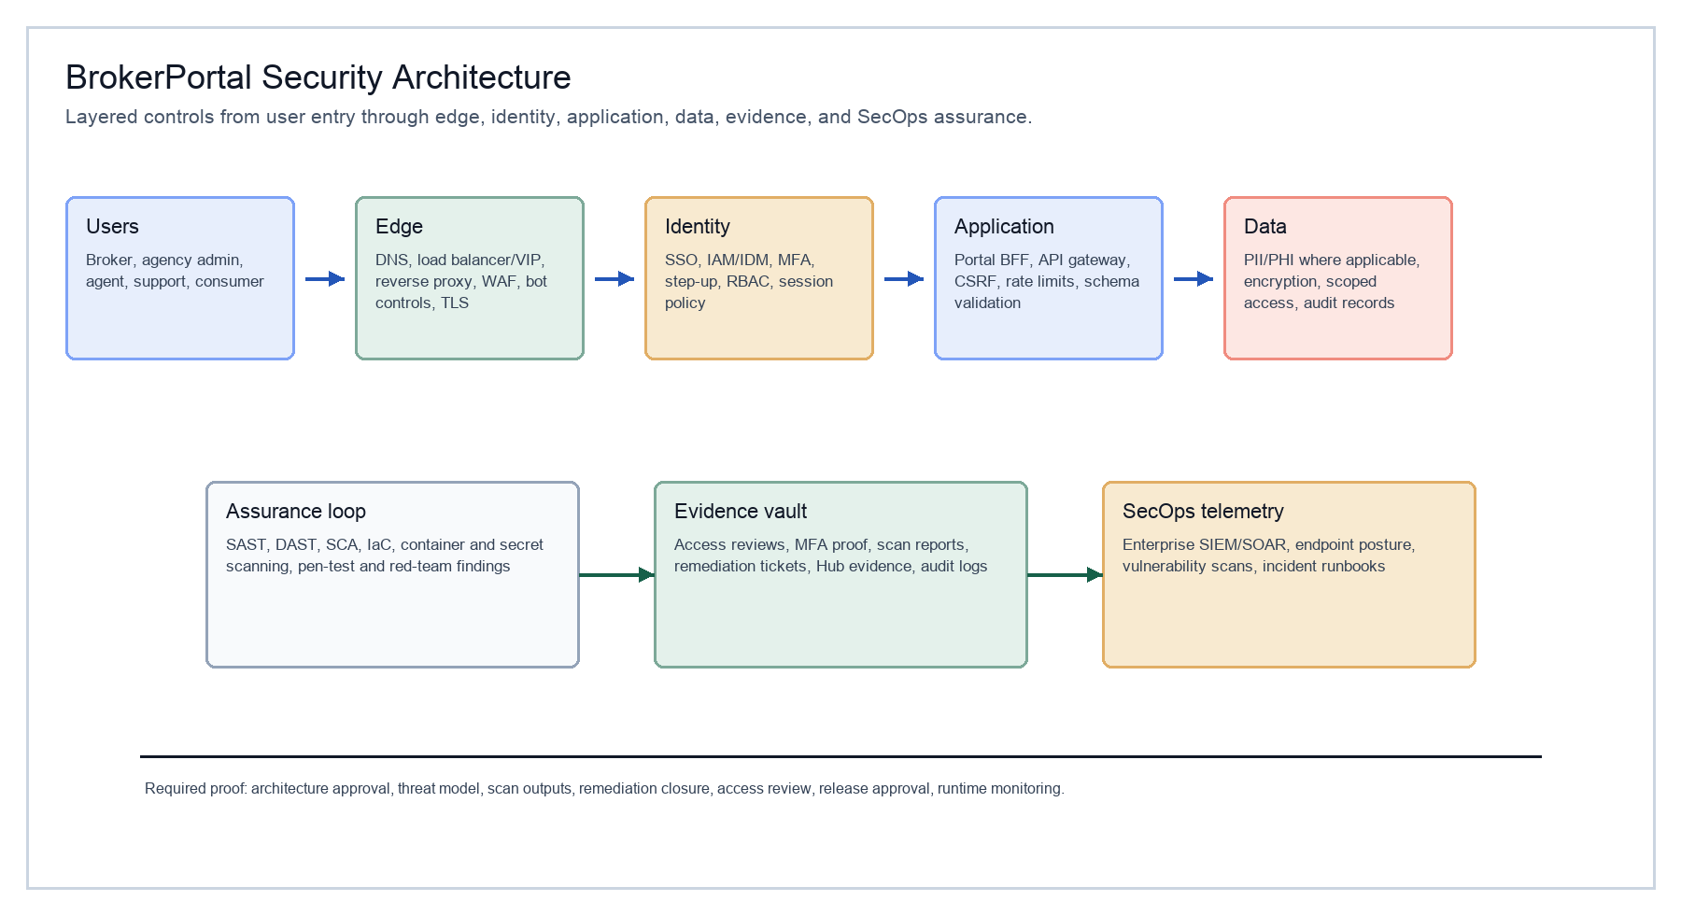
Figure 1. Layered security architecture for Broker / Agent Pathway operations.

Control architecture at a glance
Control domain | Executive purpose | Primary controls | Evidence expected
Edge and network | Protect entry points and stabilize traffic boundaries. | DNS, reverse proxy, F5 VIP, WAF, firewall, TLS/HSTS/CSP, certificate lifecycle. | WAF policy export, DNS/VIP record, TLS scan, certificate inventory, network change record.
Identity and access | Ensure only authorized users can act within permitted broker, agency, support, or consumer scope. | SSO, IAM/IDM, MFA, RBAC/ABAC, brokerId/agencyId scoping, privileged access controls. | MFA report, role matrix, access review, privileged access log, deprovisioning sample.
Application and API security | Control business actions at the service boundary. | Portal BFF, API gateway, CSRF controls, rate limiting, schema validation, secure headers, secrets/KMS. | SAST/DAST/SCA reports, secrets scan, code review evidence, threat model, release approval.
Data and integration protection | Protect PII/PHI, CMS/EDE metadata, documents, and transaction history. | Encryption, masked responses, consent records, audit logs, correlation IDs, idempotency, retention policy. | Encryption configuration, transaction evidence, audit sample, masking test, retention evidence.
SecOps and assurance | Sustain operating confidence after launch. | Tanium, Cortex, Qualys, SIEM/SOAR, vulnerability management, incident runbooks, remediation register. | Endpoint posture, vulnerability report, SIEM correlation, incident tabletop, POA&M / remediation evidence.

Evidence lifecycle and operating assurance
A control should be represented as operating only when the evidence record is dated, owner-assigned, environment-specific, and traceable to a release or operating cadence. Target-state controls should remain clearly labeled until validation is complete.
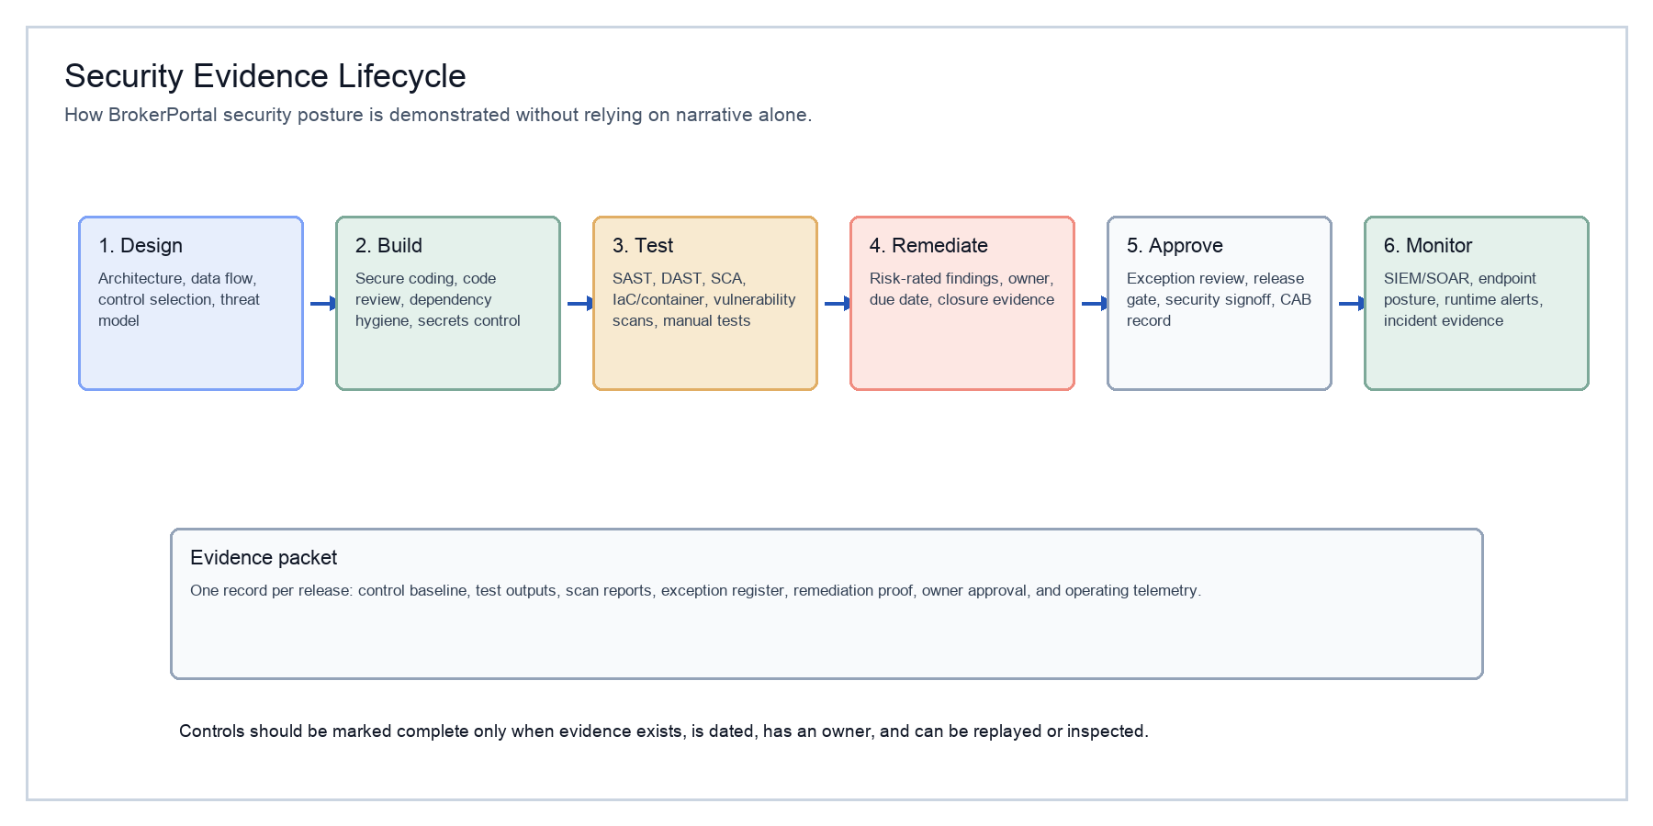
Figure 2. Evidence lifecycle from design and secure build through release, runtime monitoring, and audit response.

Production assurance cadence
Cadence | Security and governance activity | Decision-grade output
Every release | Threat model update, SAST/SCA/secrets review, DAST where applicable, access impact review, release gate approval. | Release evidence packet with open findings, disposition, owner, and go/no-go decision.
Monthly | Vulnerability posture review, remediation aging, SIEM / SecOps signal review, evidence register refresh. | Operating assurance snapshot and remediation burn-down view.
Quarterly | Access recertification, privileged access review, control evidence sampling, incident tabletop or runbook refresh where required. | Quarterly control attestation and residual risk view.
External assurance | Elevate audit / penetration testing, retest, and closure evidence once scope is approved. | Independent assurance report with findings, remediation evidence, and accepted residual risk.

Submission standard
For external or executive review, attach actual scan outputs, access reports, WAF/F5 evidence, vulnerability dispositions, penetration testing reports, and approval records. Do not describe a control as complete solely because it exists in the target architecture.

Reference anchors
Reference | Use in review | URL
NIST SP 800-207 | Zero Trust Architecture | https://csrc.nist.gov/pubs/sp/800/207/final
NIST SP 800-218 | Secure Software Development Framework | https://csrc.nist.gov/pubs/sp/800/218/final
NIST SP 800-53 Rev. 5 | Security and privacy control catalog | https://csrc.nist.gov/pubs/sp/800/53/r5/upd1/final
HHS HIPAA Security Rule | Administrative, physical, and technical safeguards | https://www.hhs.gov/hipaa/for-professionals/security/laws-regulations/index.html
CMS EDE guidance | Enhanced Direct Enrollment and audit expectations | https://www.cms.gov/marketplace-private-insurance/agents-brokers/enhanced-direct-enrollment
OWASP ASVS / Top 10 | Application security verification and common risk categories | https://owasp.org/www-project-application-security-verification-standard/

