BrokerPortal Security Testing and Release Evidence Checklist
A release-oriented checklist for documenting security validation, remediation, approvals, and evidence readiness for BrokerPortal.
Prepared for | WHPS BrokerPortal / BrokerLink security review
Document status | Controlled review draft; operating effectiveness requires dated evidence artifacts
Prepared date | May 14, 2026

Evidence boundary
This checklist defines the evidence expected for a release review. It should be populated with actual scan outputs, test results, approvals, and remediation records before controls are represented as complete.

Testing and release gate flow
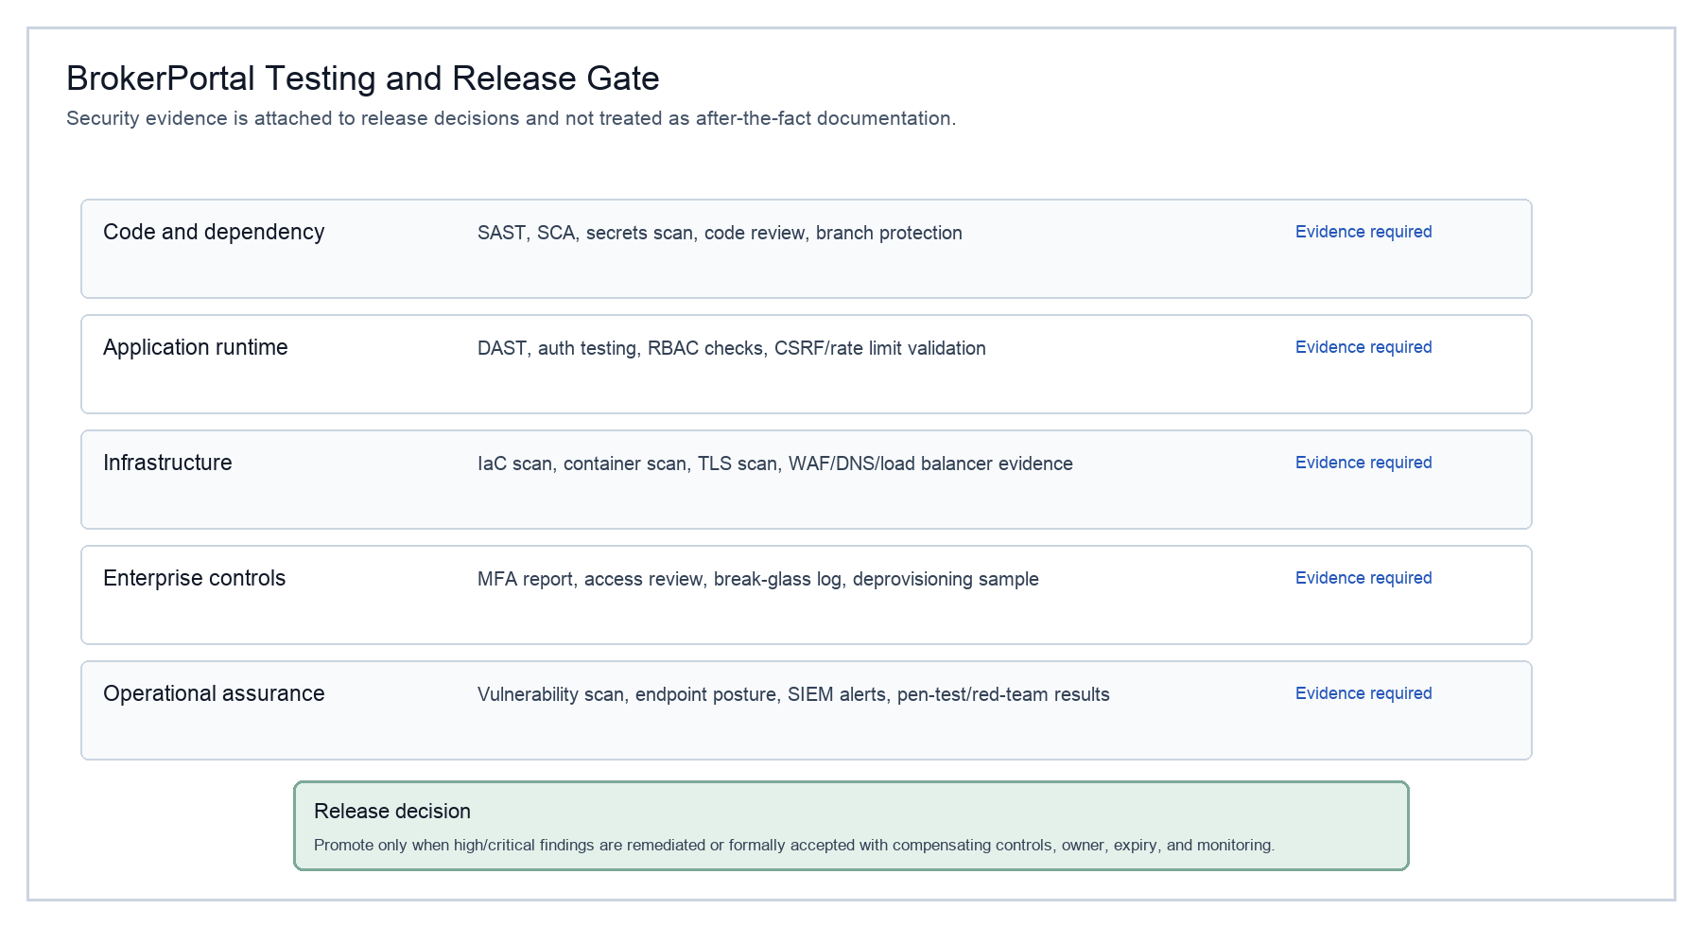
Figure 1. Testing and release gate evidence flow.

Minimum evidence checklist
Evidence item | What it validates | Artifact to attach | Readiness
Threat model | Architecture, trust boundaries, data classification, abuse cases, mitigations. | Threat model record approved by architecture and security. | Required
SAST | Code vulnerabilities, injection, auth misuse, unsafe patterns. | Tool report, triage, remediation tickets. | Required
SCA | Open-source dependency risk and license exposure. | Dependency report, critical/high disposition. | Required
Secrets scan | Hardcoded secrets, tokens, keys, certificates. | Scan result and any revocation/rotation evidence. | Required
DAST | Runtime web/API findings, auth/session, headers, OWASP issues. | DAST report, retest evidence. | Required before production
IaC/container scan | Infrastructure drift, container baseline, exposed services. | Scan report and remediation record. | Required when in scope
Vulnerability scan | Network and host posture. | Scan report and remediation/exception register. | Required before production
Pen test / red team | Manual exploitation, business logic, auth bypass, chained findings. | Attestation, findings, retest closure. | Required by policy
Access review | Users, roles, MFA, privileged access, support break-glass. | Access review signoff and exception list. | Required
Release approval | Open findings, exceptions, monitoring, rollback, support readiness. | Security release approval / CAB record. | Required

Release decision criteria
- No unresolved critical findings should remain at production release.
- High findings should be remediated or formally accepted with compensating controls, owner, expiration date, and monitoring.
- Medium findings should have an owner, target date, and risk disposition.
- Access control, MFA, broker/agency scope, protected-data masking, and audit logging should have explicit test evidence.
- Every security exception should be visible in the release decision and tracked in the POA&M or remediation register.

Remediation register template
Finding | Severity | Source | Disposition / owner | Evidence / due date
TBD | TBD | SAST / DAST / vulnerability scan / pen test / access review | Fix / accept / defer with compensating control; owner assigned | Ticket, retest, approval, report; due date

Evidence pending status
- Architecture and control model are documented.
- The evidence register identifies each required proof artifact, owner, and cadence.
- Security validation artifacts are attached as they are completed and reviewed.
- Controls without evidence remain target-state controls until evidence is approved.

Reference anchors
Reference | Use in review | URL
NIST SP 800-207 | Zero Trust Architecture | https://csrc.nist.gov/pubs/sp/800/207/final
NIST SP 800-218 | Secure Software Development Framework | https://csrc.nist.gov/pubs/sp/800/218/final
NIST SP 800-53 Rev. 5 | Security and privacy control catalog | https://csrc.nist.gov/pubs/sp/800/53/r5/upd1/final
HHS HIPAA Security Rule | Administrative, physical, and technical safeguards | https://www.hhs.gov/hipaa/for-professionals/security/laws-regulations/index.html
CMS EDE guidance | Enhanced Direct Enrollment and audit expectations | https://www.cms.gov/marketplace-private-insurance/agents-brokers/enhanced-direct-enrollment
OWASP ASVS / Top 10 | Application security verification and common risk categories | https://owasp.org/www-project-application-security-verification-standard/

